


SOUTHWEST UNIVERSITY OF SCIENCE AND TECHNOLOGY
PROJECT TITLE
CloudPOS – Role-Based Point of Sale System
TEAM MEMBERS:
FRIMPONG MAAME ACHIAA (4420230903)
TRUONG QUANG NGHIA (4420230904)
KARIM OUSSAMA (4420230906)

DEGREE: BACHELOR OF ENGINEERING
COURSE INSTRUCTOR: Dr LORD BLESS

Table of Contents
Chapter one 4
1. Introduction 4
1.1. Background 4
1.2. Problem Statement 4
1.3. Objectives 5
1.4. Scope 6
Chapter two 7
2.System Analysis and Requirements 7
2.1. System Overview 7
2.2. Functional Requirements 7
2.3. Non-Functional Requirements 8
2.4. Use Case Diagram 9
Figure 1 9
2.4.1 Explanation 9
Chapter Three 11
3. System And Software Design 11
3.1. POS System – CloudPOS - System Architecture & Design Patterns 11
3.1.1. High-Level System Architecture 11
3.1.2. Design Patterns Used 12
3.2. Object-Oriented Class Diagram 13
3.2.1. Complete UML Class Diagram 13
3.2.2. Offline Architecture 14
3.2.3. Explanation 14
3.3. Sequence Diagram 15
3.3.1. Key Relationships Summary 17
3.4. Activity Diagram 18
3.5. Work Breakdown Structure (WBS) 20
3.6. Gantt Chart 23
3.7. Activity Network Diagram 23
3.7.1. Critical Path Analysis (PERT/CPM) 24
Chapter Four 25
4. Implementation 25
4.1. Tools and Technologies 25
4.1.1. Programming Language 25
4.1.2. Graphical User Interface (GUI) Framework 25
4.1.3. Database Technologies 26
4.1.4. Cloud & Synchronization 26
4.1.5. PDF Generation (Receipts) 27
4.1.6. Development Tools 27
4.1.7. Hardware Requirements (Deployment) 28
4.2. Technology Stack Summary Diagram 29
4.3. System Architecture 30
4.3.1. High-Level Architecture Overview 30
4.3.2. Architecture Diagram 31
4.3.3. Offline-First Sync Architecture 32
4.3.4. Security Architecture 33
4.4. System Modules 34
4.5. Key Features 39
4.5.1. Feature Summary Table 39
4.6. Screenshots 41
Figure 2. Login Page 41
Figure 3. Admin’s Dashboard 41
Figure 4. Products 42
Figure 5. Cashier’s Dashboard 42
Figure 6. Manager’s Dashboard 43
Chapter Five 44
5. Testing and Evaluation 44

Chapter one

1. Introduction

1.1. Background
Retail businesses, especially small to medium-sized enterprises (SMEs), face significant operational challenges in managing over-the-counter sales, tracking staff actions, preventing revenue loss, and maintaining inventory accuracy. Traditional POS systems often lack structured shift management, granular access control, and reliable data synchronization when internet connectivity is intermittent.
The goal is to build a desktop-based POS system using Python, integrated with a cloud database, that enforces strict role-based access control (RBAC), supports shift-level accountability, and enables offline operation with cloud synchronization.
Key Technical Drivers
- Cloud-First but Offline-Capable: Centralized data management with local resilience.
- Role-Based Access Control (Admin, Manager, Cashier): Prevents unauthorized actions and reduces internal fraud.
- Shift-Level Reconciliation: Ens every cashier’s session is tracked from opening to closing balance.

1.2. Problem Statement
Many retail POS systems in use today suffer from the following critical issues:
- Weak Access Control – Cashiers and managers often share login credentials, leading to audit trails that cannot identify individual responsibility.
- No Formal Shift Management – There is no systematic way to track opening cash balances, sales during a shift, and closing counts, making cash theft or errors hard to detect.
- Revenue Leakage – Without split payment tracking, receipt generation, and approval workflows, revenue can be lost through unrecorded transactions or unauthorized discounts.
- Poor Offline Handling – When internet fails, many systems stop working entirely, causing business disruption.
- Inflexible User Account Creation – Public registration or insecure account creation allows unauthorized system access.
Therefore, there is a clear need for a secure, modular, offline-first POS system that enforces role hierarchy, shift accountability, and reliable transaction logging.

1.3. Objectives
1. Implement a secure authentication module using cloud authentication with hashed passwords and Row Level Security (RLS).

2. Enforce a 3-tier role hierarchy (Admin, Manager, Cashier) where only Admins can create new staff accounts.

3. Build a POS terminal with fast product search (by barcode or name), cart management, and split payment (cash + bank transfer).

4. Automatically generate PDF receipts for every completed sale (simulating thermal printer output).

5. Implement shift management: open shift (with cash input) and close shift (with counted cash and discrepancy calculation).

6. Support offline operation – continue sales when internet is lost, then sync to cloud when reconnected.

1.4. Scope
In Scope (What the Project Will Deliver)
- Fully functional desktop POS application (Windows/Linux compatible) written in Python.

- Cloud database integration with:
  - Product table (barcode, name, price, attributes, image URL)
  - Users table (hashed password, role, name, shift history)
  - Sales transaction table (items, total, split payment details, shift ID, timestamp)
  - Shift table (cashier ID, open time, close time, opening balance, closing balance, discrepancy)
- Authentication & role-based UI – Different dashboards for Admin, Manager, Cashier.
- Shift operations – Open/close shift with cash confirmation.
- Sales terminal – Cart, payment, change calculation, split payment, PDF receipt.
- Product management (CRUD) – Only for Admin and Manager, with validation.
- Offline-first sync mechanism – Local queue + cloud upload on reconnect.
- Basic reporting – Shift summary, sales by date.

Chapter two

2.System Analysis and Requirements

2.1. System Overview
The Point of Sale (POS) System is designed to manage retail sales operations efficiently, securely, and reliably. It allows cashiers to process customer purchases, accept payments, generate receipts, and manage daily register activities.
The system supports different user roles such as Admin, Manager, and Cashier, where each role has specific permissions based on responsibility. Cashiers handle daily transactions, managers supervise sales and cash activities, and admins manage users, roles, and system settings.
A key part of the system is its offline-first capability. Sales can continue even when there is no internet connection by storing data locally in SQLite. Once the connection is restored, the system synchronizes the local data with the central PostgreSQL database.

2.2. Functional Requirements
The system consists of the following core modules:
1. Module Authentication & Role Management
- Centralized Login: Uses Cloud Auth for user authentication.
- 3-Tier Role Hierarchy:
Admin: Full authority to manage staff accounts and access all system functions.
Manager: Manages products, approves sensitive tasks, and handles shift reconciliation.
Cashier: Limited to opening/closing shifts and performing sales transactions.
- Restriction on Public Registration: Only Admins have the authority to create new staff accounts.

2. Module POS Terminal (Sales & Payment)
- High-Speed Operations: Fast product searching via text box (supports barcode or product name).
- Cart Management: Add, edit quantities, and remove items from the cart.
- Flexible Payment: Processes payments and automatically calculates change. Supports Split Payment (e.g., partial cash and partial bank transfer).
- Receipt Generation: Exports transaction invoices as PDF files (simulating thermal printing) for storage and verification.

3. Module Inventory & Product Management
- Product Lifecycle Management (CRUD): Add, View, Update, and Delete product information (Barcode, Name, Price, Attributes).
- Image Management: Store and retrieve product images via Cloud Storage or local offline storage.

4. Module Shift Management
- Open Shift: Requires the cashier to confirm the opening cash balance in the till before selling.
- Close Shift: The cashier enters the actual counted amount at the end of the shift.

2.3. Non-Functional Requirements
1. Performance: Database optimized with SQL Indexes to ensure fast product querying and invoice generation.

2. Security: Passwords are hashed one-way by Cloud Auth. Implements Row Level Security (RLS) to secure the database.

3. Usability: Interface uses standard technical English with a minimalist design, focusing on Data Grids instead of large graphical buttons.

4. Maintainability: Source code architecture is clearly separated into modules: UI Logic, Database Access, and Business Logic.

2.4. Use Case Diagram
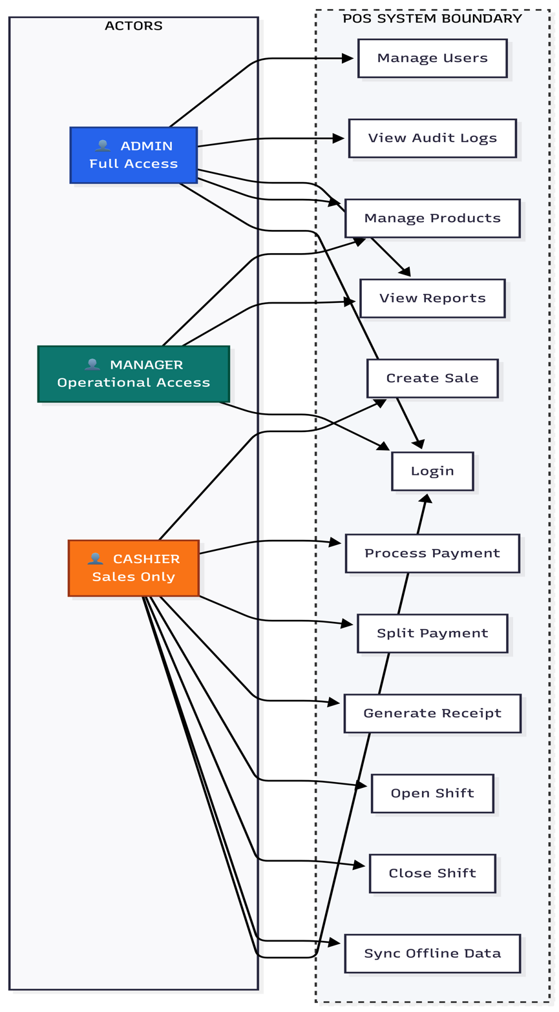

Figure 1

2.4.1 Explanation
The diagram represents a Point of Sale (POS) system where three main actors Cashier, Manager, and Admin interact with the system based on their responsibilities.
- The Cashier handles day-to-day operations like creating sales, processing payments, and managing the register during a shift.
- The Manager oversees operations, monitors performance, and reviews reports and cash activities.
- The admin controls the system at a higher level, including managing users, permissions, and overall system configuration.
All interactions happen inside the POS system boundary, which groups core business processes such as sales handling, cash/register control, reporting, user management, hardware usage, offline operation, and security.
The diagram shows how:
- Complex actions (like completing a sale or generating reports) are made up of smaller required steps (<<include>> relationships).
- The system supports real-world retail workflows, including handling cash, tracking user actions, and integrating with hardware.
- It is designed to be offline-first, meaning operations continue locally and sync later with a central system.
- Security and audit mechanisms ensure traceability and controlled access.

Chapter Three

3. System And Software Design

3.1. POS System – CloudPOS - System Architecture & Design Patterns

3.1.1. High-Level System Architecture
The system follows a Layered (N-Tier) Architecture combined with an Offline-First Cloud Sync Pattern. This ensures separation of concerns, maintainability, and resilience to network failures.
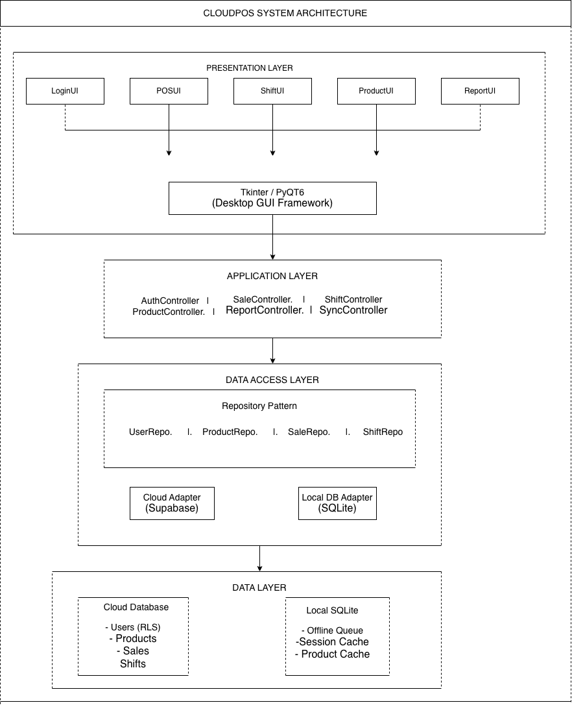

3.1.2. Design Patterns Used
Pattern | Purpose | Location in System
Repository Pattern | Abstracts data access logic, allows switching between cloud/local sources | data_access/repositories/
Singleton Pattern | Ensures single instance of database connections and sync manager | DatabaseConnection, SyncManager
Factory Pattern | Creates appropriate repository based on connectivity status | RepositoryFactory
Observer Pattern | UI updates when cart changes or sync completes | EventBus – cart update listeners, sync status listeners
Strategy Pattern | Different payment methods (cash, bank transfer, split) | PaymentStrategy interface
Command Pattern | Queues offline transactions for later execution | OfflineCommand (SaleCommand, ProductUpdateCommand)
Decorator Pattern | Adds receipt formatting options (header, footer, discounts) | ReceiptDecorator
MVC Pattern | Separates UI, logic, and data | Overall architecture

3.2. Object-Oriented Class Diagram

3.2.1. Complete UML Class Diagram
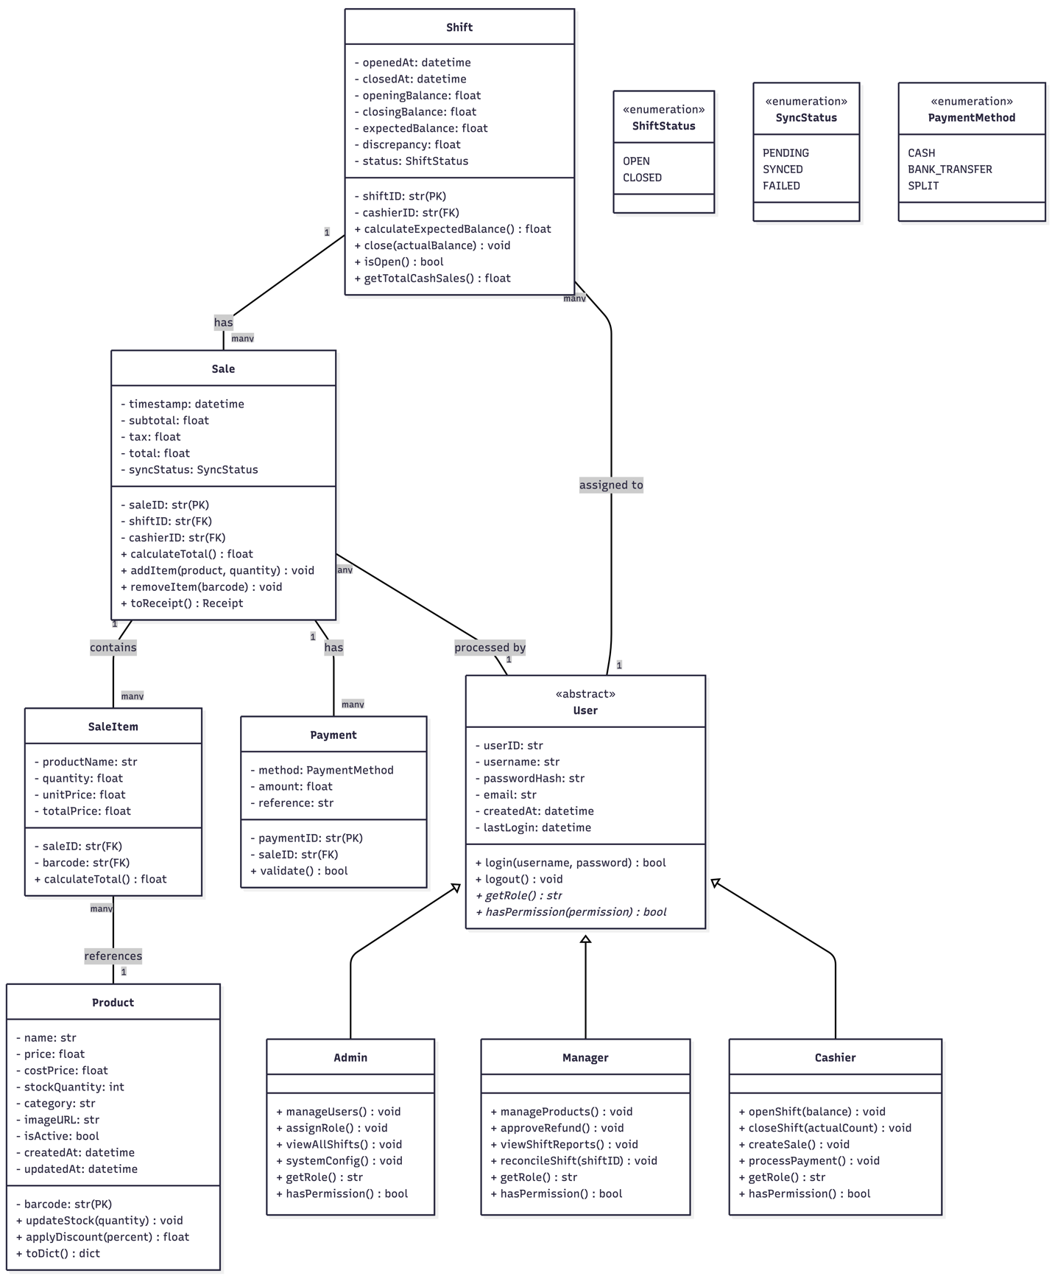

3.2.2. Offline Architecture

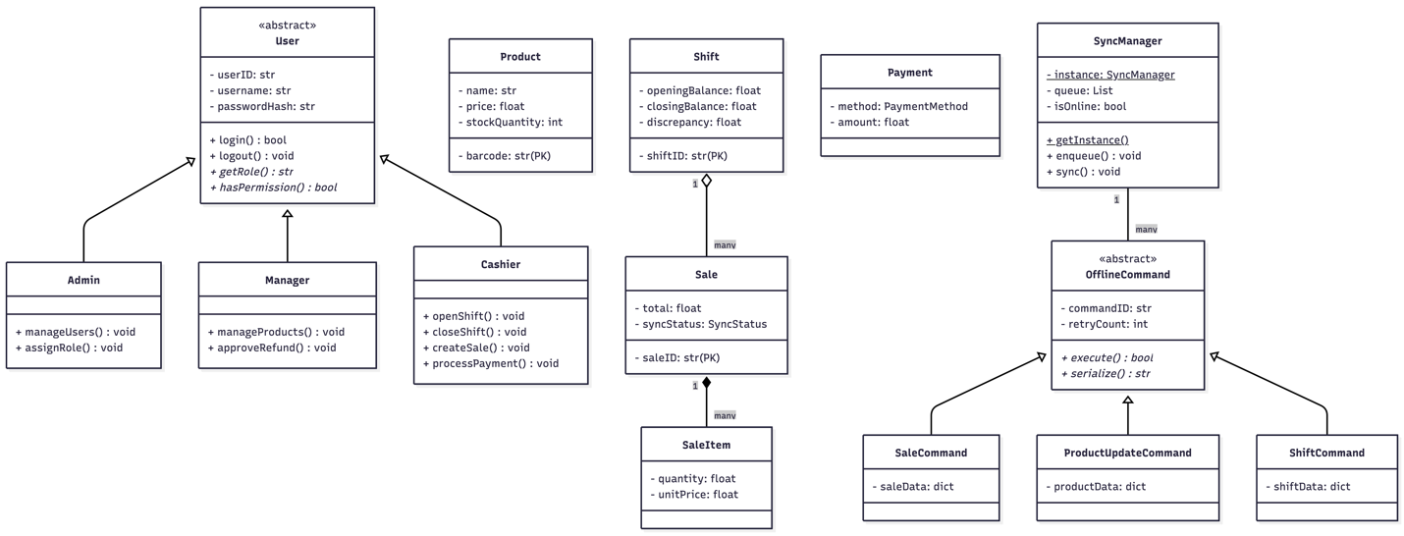

3.2.3. Explanation
Abstract Class Diagram
The Abstract Class Diagram illustrates the core object-oriented structure of the CloudPOS system. At the center is the abstract User class, which cannot be instantiated directly but serves as a blueprint for three specific user roles: Admin, Manager, and Cashier. The abstract class contains common attributes such as userID, username, passwordHash, and email, along with concrete methods like login() and logout() that work identically for all users. Two abstract methods, getRole() and hasPermission(), force each subclass to define its own role name and permission boundaries.
The Admin has full system access with methods to manage users and assign roles. The Manager has limited access focused on product management and shift reconciliation. The Cashier has minimal access restricted to opening shifts, creating sales, and processing payments. This three-tier hierarchy enforces strict role-based access control.
The diagram also shows four core business entities. Product stores item details including barcode, name, price, and stock quantity. Shift tracks each cashier's work session with opening balance, closing balance, expected balance, and discrepancy calculation—critical for preventing revenue leakage. Sale represents a customer transaction linked to a specific shift and cashier. SaleItem records individual line items within a sale, storing denormalized product names to preserve historical accuracy even if product information changes later.

Offline Command Diagram
The Offline Command Diagram shows how the system maintains functionality during network outages. At the top is the abstract OfflineCommand class, which defines attributes like commandID, type, createdAt, and retryCount, along with abstract methods execute() and serialize(). Three concrete command classes inherit from it: SaleCommand, ProductUpdateCommand, and ShiftCommand. Each stores the relevant data as a dictionary and implements the execute method to upload to the cloud when online.
The SyncManager uses the Singleton pattern, ensuring only one instance exists. It maintains a queue of pending commands, monitors network connectivity through the isOnline flag, and provides methods to enqueue commands and trigger synchronization. When the system is online, commands execute immediately on the cloud database. When offline, commands are serialized to JSON and stored in a local SQLite queue. Upon reconnection, the SyncManager flushes the queue in FIFO order, with failed commands retrying up to three times. This architecture ensures business continuity during internet outages while maintaining data integrity.

3.3. Sequence Diagram
Login and Authentication Sequence
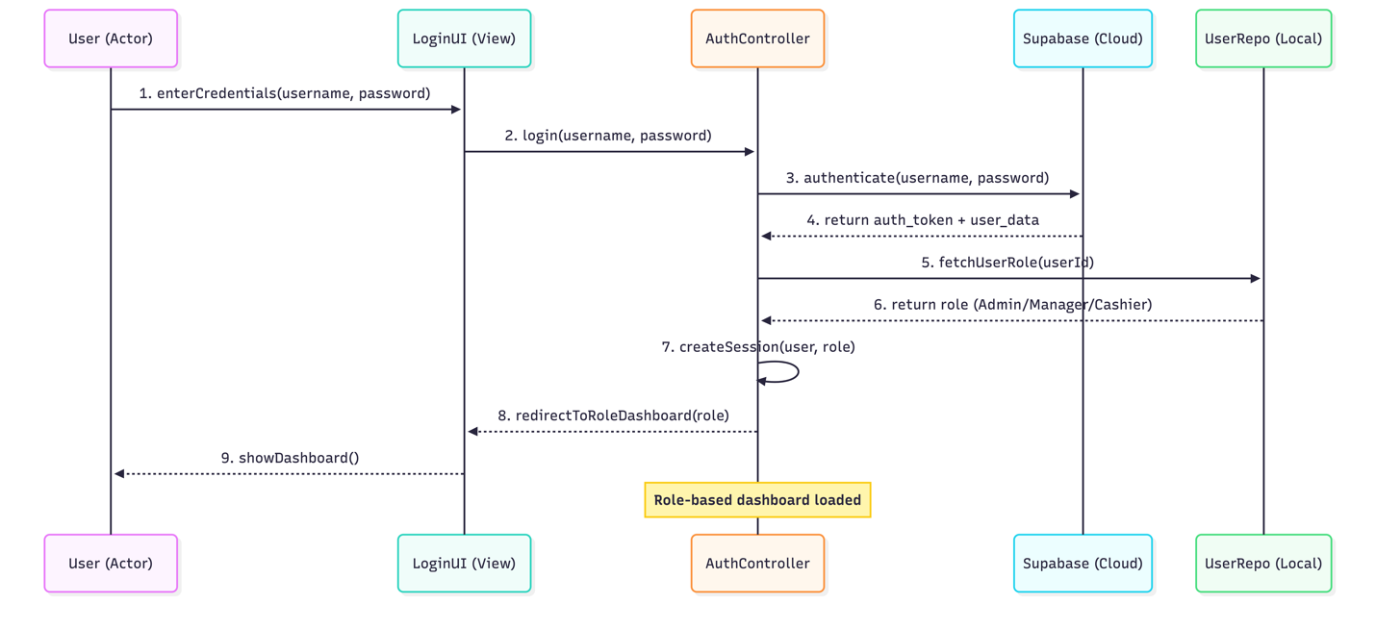

Open Shift Sequence
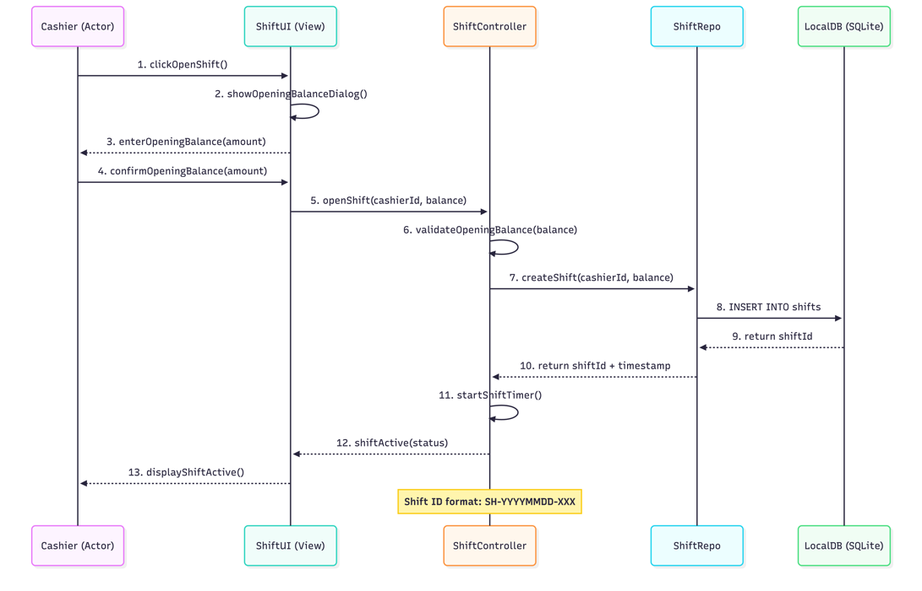

Create Sale and Process Payment Sequence
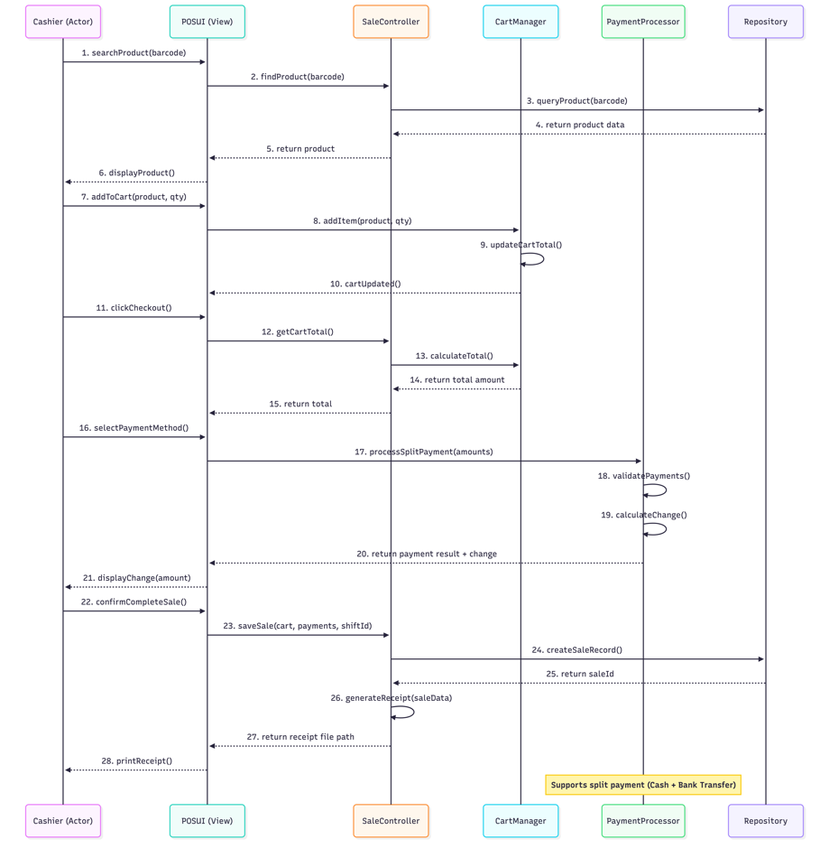

3.3.1. Key Relationships Summary
Relationship | From | To | Cardinality
Inheritance | Admin, Manager, Cashier | User | -
Composition | Sale | SaleItem | 1 : *
Aggregation | Shift | Sale | 1 : *
Association | Sale | Payment | 1 : *
Dependency | ShiftController | Shift | -
Realization | SaleCommand | OfflineCommand | -

3.4. Activity Diagram
Login and Authentication Activity Diagram

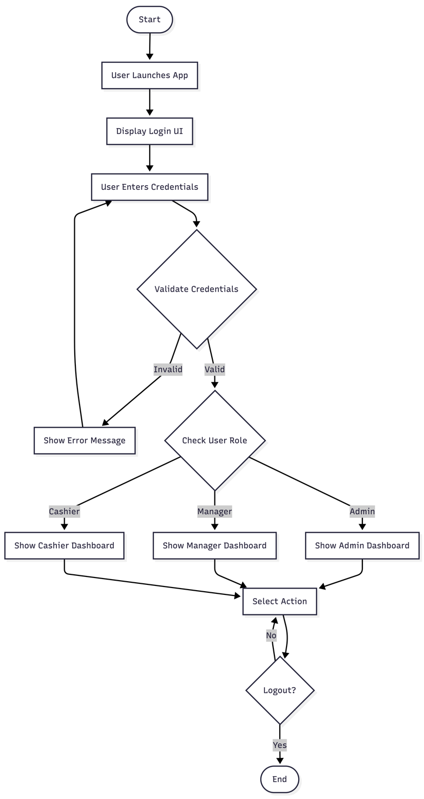

Open Shift Activity Diagram
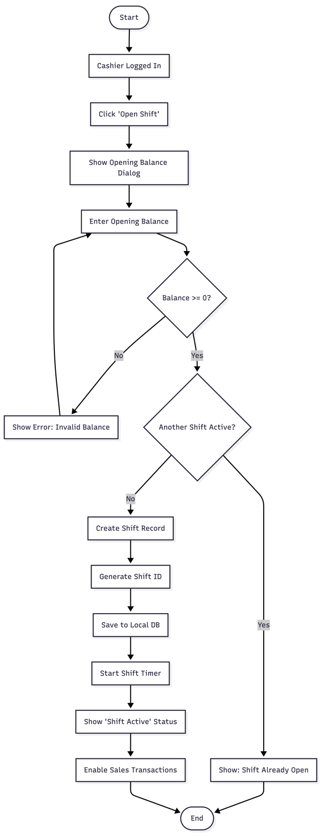

3.5. Work Breakdown Structure (WBS)
CloudPOS Project
│
├── 1.0 Project Management (5 days)
│ ├── 1.1 Requirements Analysis
│ ├── 1.2 System Design Documentation
│ ├── 1.3 Technology Selection
│ └── 1.4 Sprint Planning
│
├── 2.0 Database Design & Cloud Setup (4 days)
│ ├── 2.1 Cloud Platform Selection (Supabase/Firebase)
│ ├── 2.2 Database Schema Design
│ ├── 2.3 Row Level Security (RLS) Policies
│ ├── 2.4 Local SQLite Schema
│ └── 2.5 Offline Queue Table Design
│
├── 3.0 Authentication & Role Management (4 days)
│ ├── 3.1 Login UI
│ ├── 3.2 Password Hashing Integration
│ ├── 3.3 Role-Based UI Routing
│ ├── 3.4 Admin User Management (CRUD)
│ └── 3.5 Session Management & Logout
│
├── 4.0 Product Management Module (4 days)
│ ├── 4.1 Product CRUD UI (Manager/Admin)
│ ├── 4.2 Barcode Search Implementation
│ ├── 4.3 Product Image Upload/Retrieval
│ ├── 4.4 Stock Quantity Tracking
│ └── 4.5 Database Indexing for Fast Search
│
├── 5.0 POS Terminal Module (6 days)
│ ├── 5.1 Cart UI (Add/Edit/Remove)
│ ├── 5.2 Fast Product Search (Text/Barcode)
│ ├── 5.3 Subtotal & Tax Calculation
│ ├── 5.4 Payment Processing UI
│ ├── 5.5 Split Payment Logic
│ ├── 5.6 Change Calculation
│ └── 5.7 PDF Receipt Generation
│
├── 6.0 Shift Management Module (4 days)
│ ├── 6.1 Open Shift UI (Opening Balance)
│ ├── 6.2 Close Shift UI (Actual Count)
│ ├── 6.3 Expected Balance Calculation
│ ├── 6.4 Discrepancy Reporting
│ └── 6.5 Shift Status Tracking
│
├── 7.0 Offline-First Sync Module (5 days)
│ ├── 7.1 Offline Command Queue
│ ├── 7.2 Network Connectivity Detection
│ ├── 7.3 SyncManager Implementation
│ ├── 7.4 Conflict Resolution Logic
│ └── 7.5 Sync Status UI Indicator
│
├── 8.0 Reporting Module (3 days)
│ ├── 8.1 Shift Summary Report
│ ├── 8.2 Sales by Date/Cashier
│ ├── 8.3 Top Products Report
│ └── 8.4 Export to CSV/PDF
│
├── 9.0 Monitoring & Audit (3 days)
│ ├── 9.1 Audit Logging
│ ├── 9.2 Low Stock Alerts
│ ├── 9.3 Discrepancy Warnings
│ └── 9.4 Sync Health Dashboard
│
├── 10.0 Testing & QA (5 days)
│ ├── 10.1 Unit Testing (Controllers)
│ ├── 10.2 Integration Testing (Cloud Sync)
│ ├── 10.3 Offline Mode Testing
│ ├── 10.4 Role Permission Testing
│ └── 10.5 UAT & Bug Fixing
│
└── 11.0 Deployment & Documentation (3 days)
├── 11.1 Executable Build (PyInstaller)
├── 11.2 User Manual
├── 11.3 Technical Documentation
└── 11.4 Final Presentation Preparation

3.6. Gantt Chart

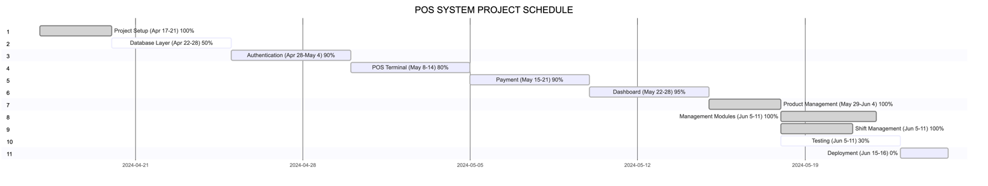

3.7. Activity Network Diagram
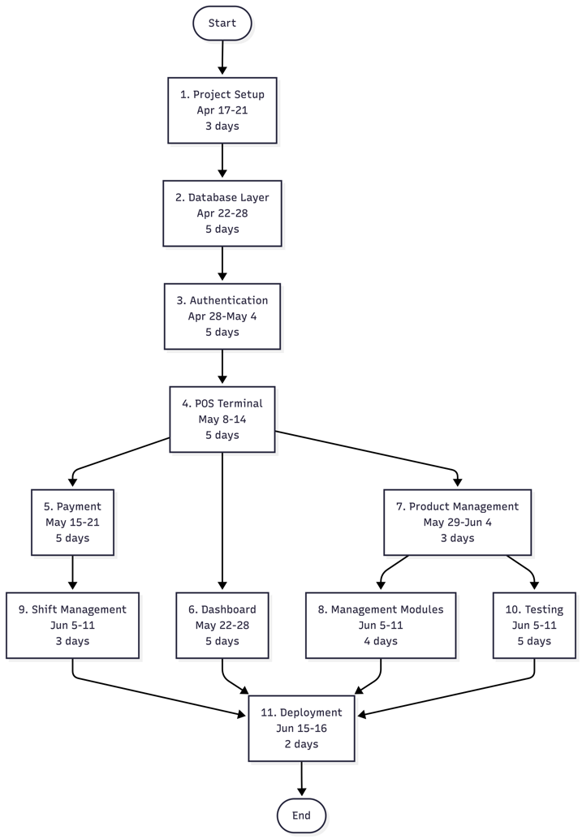

3.7.1. Critical Path Analysis (PERT/CPM)
Task | Duration | Predecessors | ES | EF
1.0 Setup | 3 | - | 0 | 3
2.0 Database | 5 | 1.0 | 3 | 8
3.0 Authentication | 4 | 2.0 | 8 | 12
4.0 POS Terminal | 8 | 2.0, 3.0 | 12 | 20
5.0 Payment | 5 | 4.0 | 20 | 25
6.0 Dashboard | 3 | 4.0 | 20 | 23
7.0 Product Mgmt | 4 | 4.0 | 20 | 24
8.0 Admin Modules | 5 | 7.0 | 24 | 29
9.0 Shift Mgmt | 3 | 5.0 | 25 | 28
10.0 Styling | 3 | 8.0 | 29 | 32
11.0 Testing | 4 | 10.0 | 32 | 36
12.0 Deployment | 2 | 11.0 | 36 | 38
Project Completion = 38 days
The POS Terminal module (Task 4.0) is the most critical task because:
- It takes 8 days (longest single task)
- Three other tasks (5.0, 6.0, 7.0) depend on it
- Any delay here directly extends the project by the same amount

Chapter Four

4. Implementation

4.1. Tools and Technologies

4.1.1. Programming Language
Technology | Version | Purpose
Python | 3.12 | Core programming language for desktop application development
Why Python?
- Rapid development and prototyping capabilities
- Extensive library support for GUI, database, PDF generation, and cloud integration
- Cross-platform compatibility (Windows, Linux, macOS)
- Strong community support for POS system development

4.1.2. Graphical User Interface (GUI) Framework
Technology | Version | Purpose
Tkinter | Built-in Python 3 | Primary UI framework for desktop application
ttk | Built-in | Themed widgets for modern appearance
Pillow (PIL) | 9.0+ | Image handling and product image display
Alternative Considered: PyQt6 (more advanced but heavier)
Selected: Tkinter – Lightweight, no additional dependencies, sufficient for minimalist data-grid design.

4.1.3. Database Technologies
Technology | Version | Purpose
Supabase | Latest | Cloud database with built-in authentication and Row Level Security (RLS)
PostgreSQL | 14+ | Underlying cloud database (provided by Supabase)
SQLite | 3.x | Local offline database for queue storage and caching
Why Supabase?
- Built-in authentication with password hashing
- Row Level Security (RLS) for role-based data access
- Real-time capabilities for sync status
- PostgreSQL compatibility (indexes, complex queries)
Why SQLite?
- Zero-configuration local storage
- ACID compliance for transaction safety
- Perfect for offline command queue

4.1.4. Cloud & Synchronization
Technology | Version | Purpose
Supabase Client | 2.0+ | Python client for cloud database operations
Requests | 2.28+ | HTTP requests for cloud API calls
Python-dotenv | 1.0+ | Environment variable management for credentials

4.1.5. PDF Generation (Receipts)
Technology | Version | Purpose
ReportLab | 3.6+ | PDF generation for transaction receipts
FPDF | 1.7+ | Alternative lightweight PDF generator

4.1.6. Development Tools
Tool | Version | Purpose
VS Code | Latest | Integrated development environment
Git | 2.40+ | Version control
GitHub | - | Remote repository and collaboration
Postman | Latest | API testing for cloud endpoints
DB Browser for SQLite | 3.12+ | Local database inspection
Draw.io | - | Diagram creation (architecture, class diagram)
PyInstaller | 5.0+ | Executable build for distribution
Mermaid Live Editor - Diagram creation (class diagram, gantt chart, activity diagram)

4.1.7. Hardware Requirements (Deployment)
Component | Minimum Specification
Processor | Intel Core i3 or equivalent
RAM | 4 GB
Storage | 500 MB free space
Display | 1366×768 resolution
Network | Wi-Fi/Ethernet (intermittent connectivity acceptable)
OS | Windows 10/11, macOS 11+

4.2. Technology Stack Summary Diagram
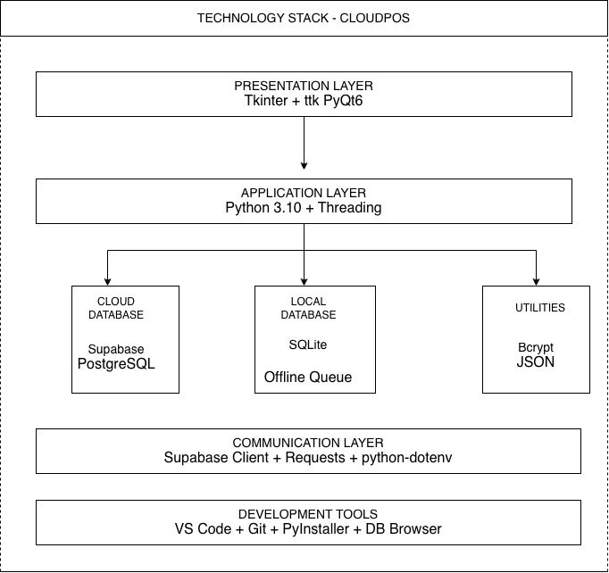

4.3. System Architecture

4.3.1. High-Level Architecture Overview

The CloudPOS system follows a Layered (N-Tier) Architecture with Offline-First capabilities. The architecture is divided into four distinct layers:
Layer | Responsibility | Components
Presentation Layer | User interface and user interaction | Tkinter windows, dialogs, data grids
Business Logic Layer | Core application logic and rules | Controllers, validators, calculators
Data Access Layer | Database abstraction and synchronization | Repositories, SyncManager, Cloud/Local adapters
Data Layer | Persistent storage | Supabase Cloud, SQLite Local

4.3.2. Architecture Diagram
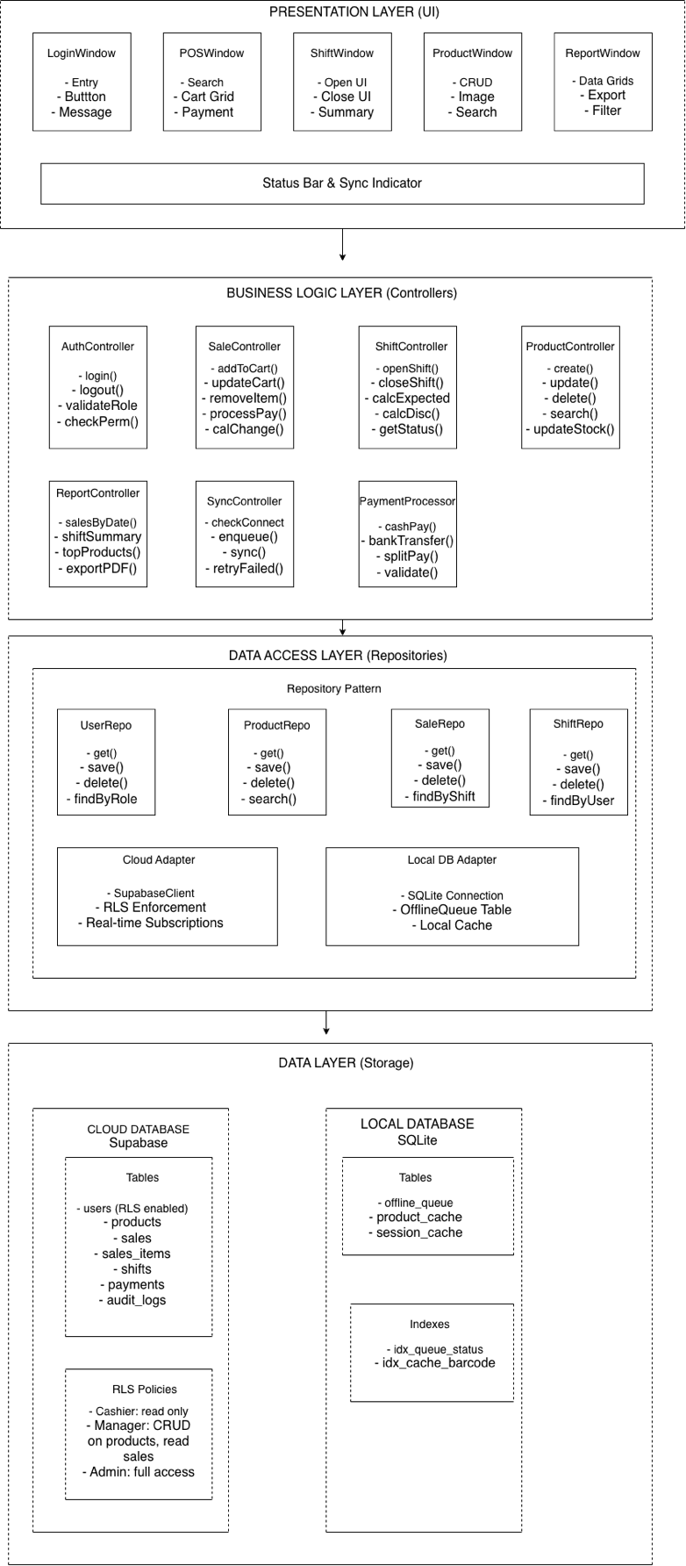

4.3.3. Offline-First Sync Architecture
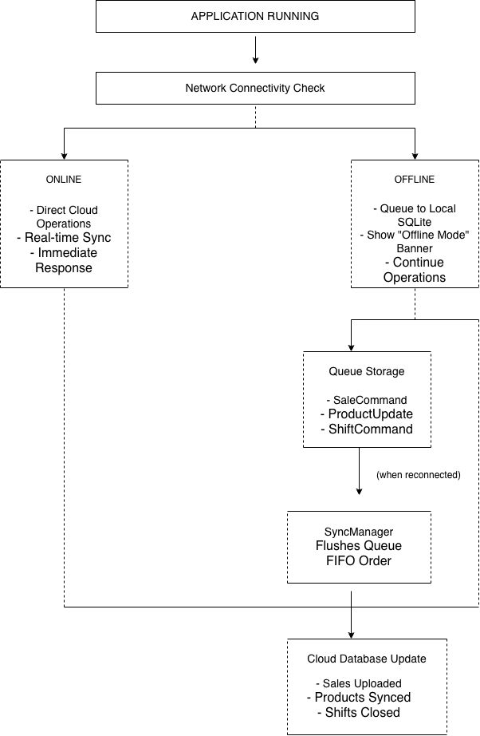

4.3.4. Security Architecture

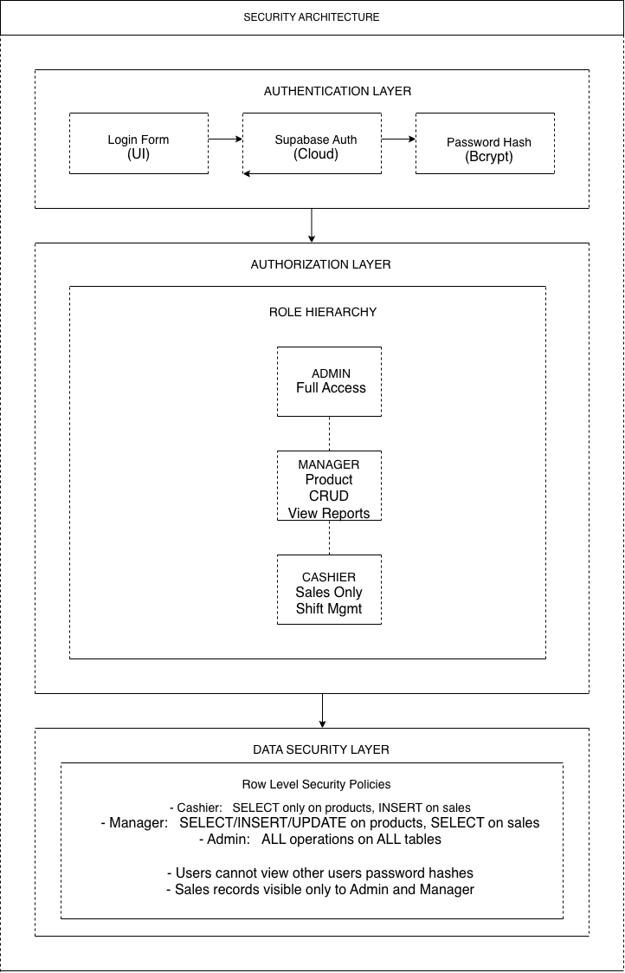

4.4. System Modules
The system is divided into seven core modules, each responsible for a specific functional area.
Module 1: Authentication & Role Management
Purpose: Secure user login and role-based access enforcement.
Components:
- Login UI with credential validation
- Password hashing (Supabase Auth)
- Session management with timeout
- Role-based dashboard routing
- Admin-only user management (CRUD)

Key Files:
/modules/auth/
├── login_window.py
├── auth_controller.py
├── session_manager.py
└── role_decorator.py

Module 2: POS Terminal (Sales & Payment)
Purpose: High-speed checkout operations with cart management and split payments.
Components:
- Product search (barcode/name) with auto-suggest
- Shopping cart UI (add, edit quantity, remove)
- Subtotal, tax, total calculation
- Payment processing (cash, bank transfer, split)
- Change calculation
- PDF receipt generation
Key Files:
/modules/pos/
├── pos_window.py
├── cart_manager.py
├── payment_processor.py
├── receipt_generator.py
└── barcode_scanner.py

Module 3: Inventory & Product Management
Purpose: Complete product lifecycle management with image support.
Components:
- Product CRUD operations (Create, Read, Update, Delete)
- Barcode-based product search
- Product image upload and retrieval (cloud/local)
- Stock quantity tracking
- Category management
- Database indexing for fast search

Key Files:
/modules/inventory/
├── product_window.py
├── product_controller.py
├── product_repository.py
├── image_handler.py
└── barcode_generator.py

Module 4: Shift Management
Purpose: Track cashier work sessions and prevent revenue leakage.
Components:
- Open shift UI (opening balance entry)
- Close shift UI (actual cash count)
- Expected balance calculation
- Discrepancy detection and reporting
- Shift status tracking (OPEN/CLOSED)
- Shift history viewer

Key Files:
/modules/shift/
├── shift_window.py
├── shift_controller.py
├── shift_repository.py
└── shift_calculator.py

Module 5: Offline-First Synchronization
Purpose: Ensure business continuity during network outages.
Components:
- Network connectivity monitor
- Offline command queue (SQLite)
- SyncManager (Singleton pattern)
- Conflict resolution strategy
- Sync status UI indicator
- Retry mechanism for failed commands

Key Files:
/modules/sync/
├── sync_manager.py
├── offline_command.py
├── sale_command.py
├── product_update_command.py
├── shift_command.py
├── network_monitor.py
└── conflict_resolver.py

Module 6: Reporting & Analytics
Purpose: Provide business insights and operational visibility.
Components:
- Shift summary report
- Sales by date/cashier report
- Top products report
- Discrepancy report
- Export to PDF/CSV
- Data grid visualizations

Key Files:
/modules/reporting/
├── report_window.py
├── report_controller.py
├── report_generator.py
├── export_handler.py
└── chart_builder.py

Report Types:
Report Name | Data Shown | Target User
Shift Summary | Opening/closing balances, discrepancy, transaction count | Manager, Admin
Daily Sales | Total revenue, transactions, average ticket | Manager, Admin
Cashier Performance | Sales per cashier, average shift duration | Admin
Top Products | Best-selling items by quantity and revenue | Manager
Discrepancy Report | Shifts with positive/negative variance | Admin

Module 7: Audit & Monitoring
Purpose: Track all system actions and maintain security.
Components:
- Audit logger (all user actions)
- Login attempt tracking
- Shift discrepancy alerts
- Low stock notifications
- Sync health dashboar
Key Files:
/modules/monitoring/
├── audit_logger.py
├── alert_manager.py
├── health_checker.py
└── dashboard_window.py

4.5. Key Features

4.5.1. Feature Summary Table
# | Feature | Description | Implemented In
1 | Role-Based Access Control | 3-tier hierarchy (Admin, Manager, Cashier) with strict permissions | Module 1
2 | Secure Authentication | Cloud-based password hashing, no plain-text storage | Module 1
3 | Fast Product Search | Barcode/name search with database indexing (<500ms response) | Module 2
4 | Shopping Cart | Add, edit quantities, remove items in real-time | Module 2
5 | Split Payment | Partial cash + partial bank transfer in single transaction | Module 2
6 | PDF Receipts | Automatic receipt generation after each sale | Module 2
7 | Product Management | Full CRUD operations with image support | Module 3
8 | Shift Opening | Cashier confirms opening balance before sales | Module 4
9 | Shift Closing | Actual cash count vs. expected balance with discrepancy | Module 4
10 | Offline-First Sync | Continue sales offline, auto-sync when reconnected | Module 5
11 | Conflict Resolution | Cloud-wins for products, local-wins for sales | Module 5
12 | Sync Status Indicator | Real-time connectivity and sync status in UI | Module 5
13 | Sales Reports | Daily, shift, and cashier performance reports | Module 6
14 | Audit Trail | Complete log of all user actions | Module 7
15 | Low Stock Alerts | Automatic notification when stock < threshold | Module 7

4.6. Screenshots
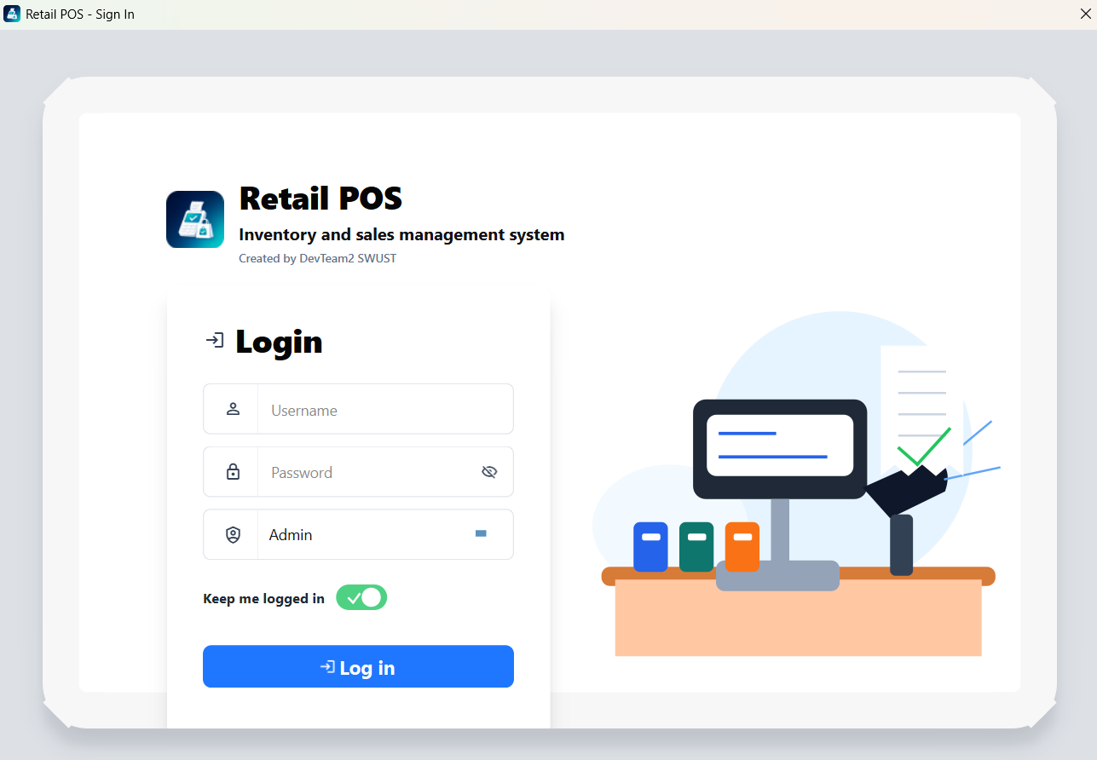

Figure 2. Login Page
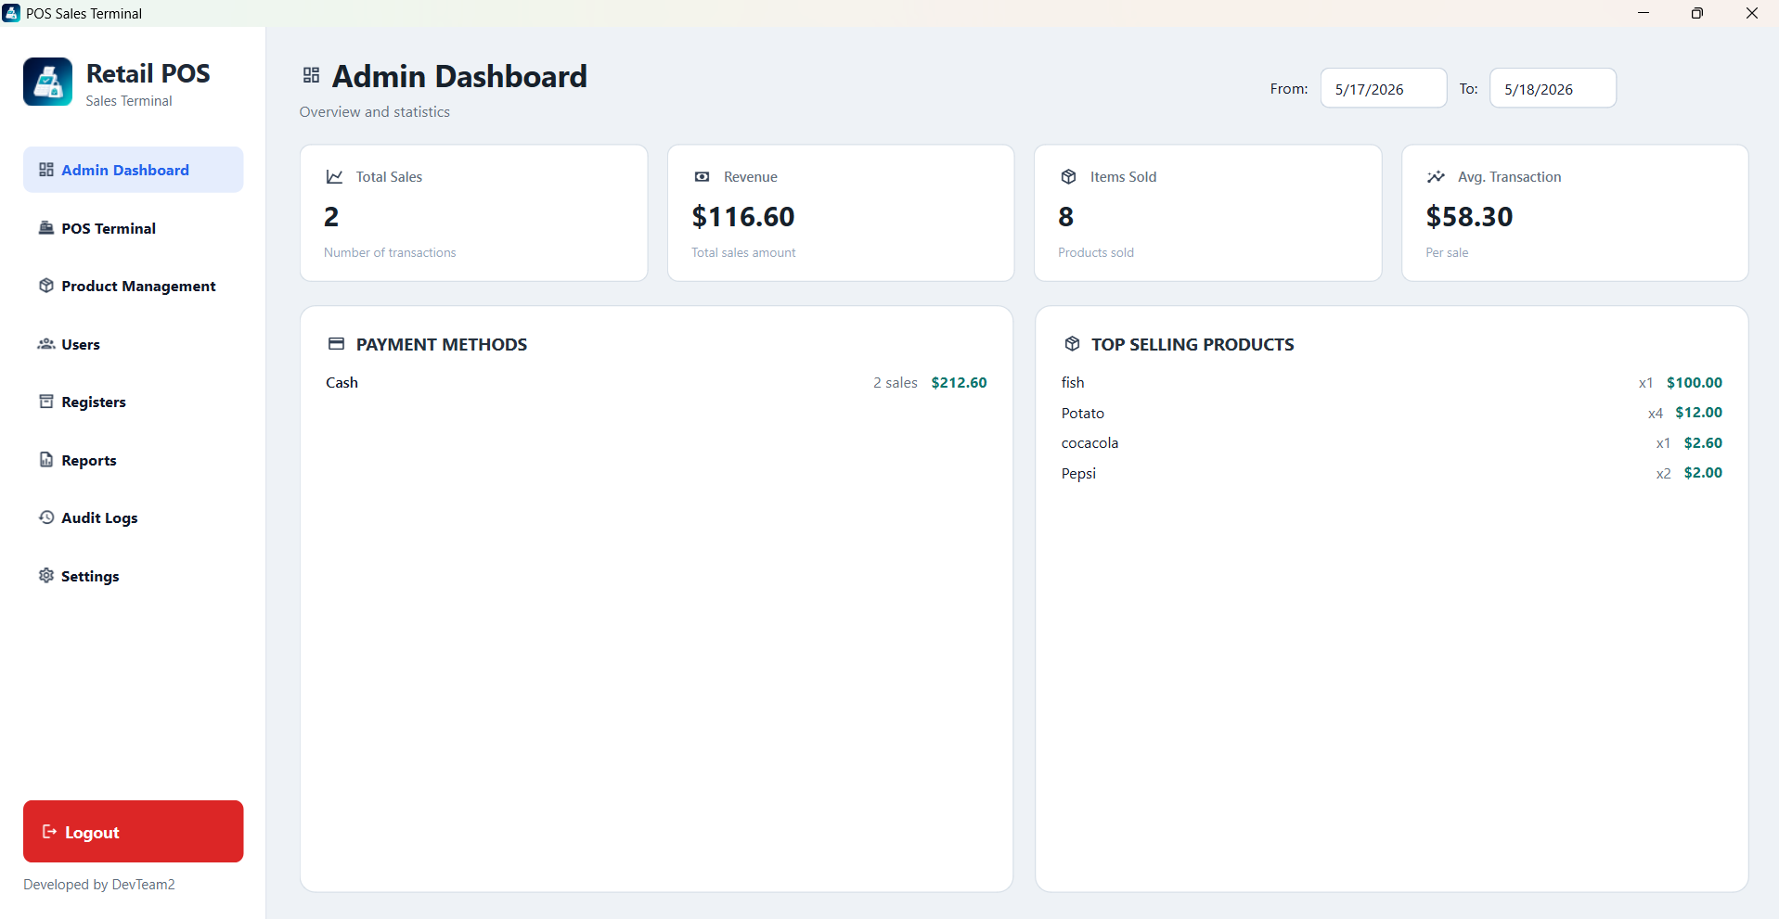

Figure 3. Admin’s Dashboard

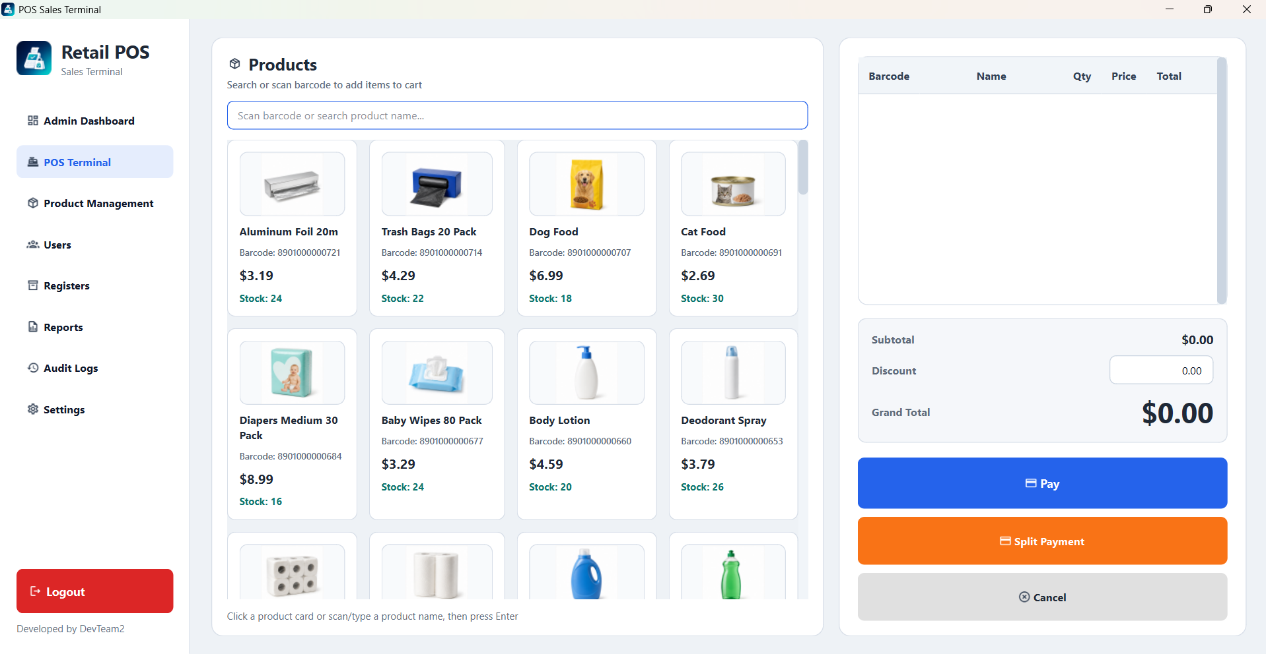

Figure 4. Products
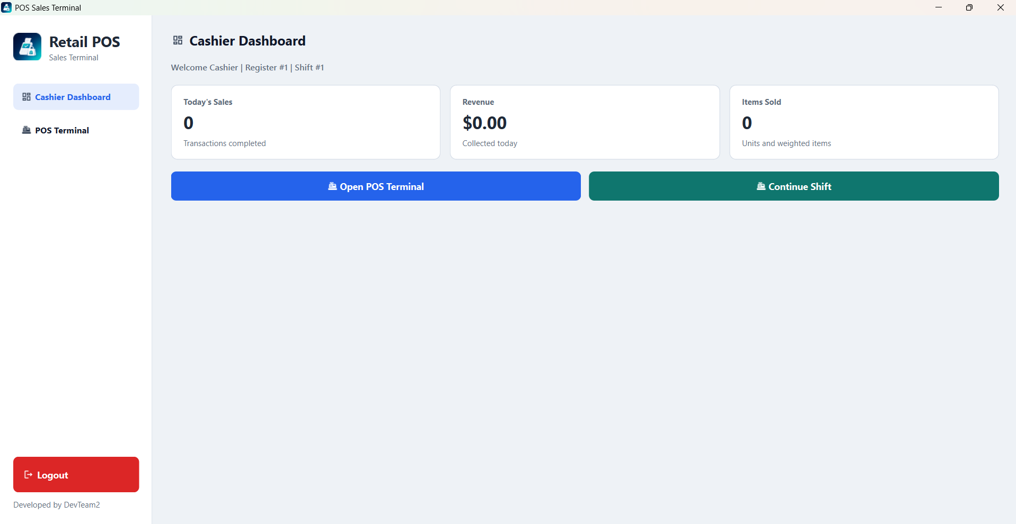

Figure 5. Cashier’s Dashboard

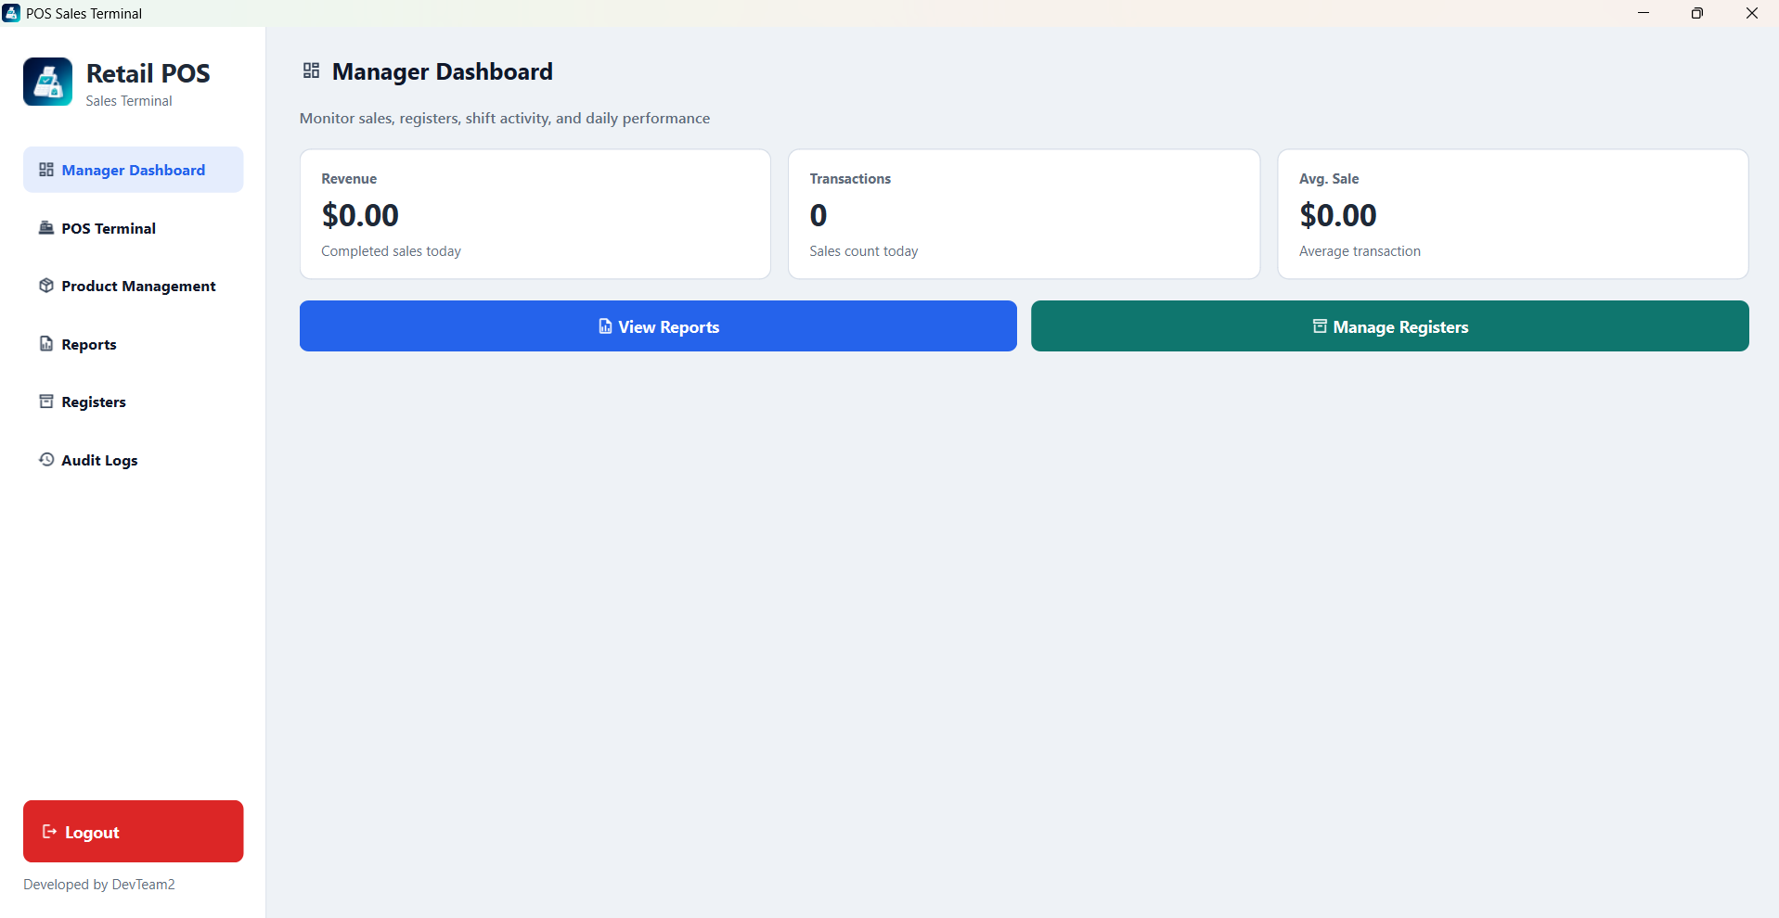

Figure 6. Manager’s Dashboard

Chapter Five

Testing and Evaluation

5.1 Test Cases
The testing process was conducted to evaluate the functionality, stability, and reliability of the POS system under different operational scenarios. The system was tested using manual testing methods to verify that all major operations work correctly and consistently.
Test ID | Test Description | Test Input / Action | Expected Result | Actual Result | Status
TC-01 | User Login Authentication | Enter valid username and password | User successfully logs into the system | Login completed successfully | Passed
TC-02 | Invalid Login Validation | Enter incorrect username or password | System displays warning message | Warning message displayed correctly | Passed
TC-03 | Session Persistence | Enable “Keep Me Logged In” and restart application | User session remains active | Session restored successfully | Passed
TC-04 | Product Search Function | Search product using barcode or product name | Correct product displayed instantly | Product displayed correctly | Passed
TC-05 | Add Product to Cart | Select product from product list | Product added into cart | Product added successfully | Passed
TC-06 | Repeated Barcode Scan | Scan same barcode multiple times | Product quantity increases automatically | Quantity updated correctly | Passed
TC-07 | Quantity Update Validation | Increase and decrease product quantity | Cart updates accurately | Quantity updated successfully | Passed
TC-08 | Stock Availability Validation | Attempt to sell out-of-stock item | System prevents invalid sale | Warning displayed correctly | Passed
TC-09 | Cash Payment Processing | Complete transaction using cash payment | Sale processed successfully | Payment completed successfully | Passed
TC-10 | Bank Transfer Payment | Select bank transfer payment method | QR and bank details displayed | Payment information shown correctly | Passed
TC-11 | Split Payment Function | Use multiple payment methods in one transaction | System accepts split payment | Transaction processed correctly | Passed
TC-12 | Receipt Preview Generation | Complete payment successfully | Receipt preview displayed | Receipt generated correctly | Passed
TC-13 | Sales Record Storage | Finish transaction process | Sales data saved into database | Database updated successfully | Passed
TC-14 | Payment Record Validation | Complete payment transaction | Payment information stored correctly | Payment data saved successfully | Passed
TC-15 | Product Information Management | Add or edit product information | Product details updated in system | Product updated successfully | Passed
TC-16 | Product Image Upload | Upload image for product | Product image displayed correctly | Image uploaded successfully | Passed
TC-17 | Multiple Barcode Support | Assign multiple barcodes to one product | Product searchable by all barcodes | Function worked correctly | Passed
TC-18 | Role-Based Access Control | Login using different user roles | Appropriate dashboard displayed | Access permissions worked correctly | Passed
TC-19 | Report Generation | Generate sales report | Report displayed accurately | Report generated successfully | Passed
TC-20 | Logout Functionality | Logout from system | User session terminated securely | Logout completed successfully | Passed

5.2. Functional Testing

5.2 System Performance
The POS system demonstrated stable and responsive performance during testing. The application was developed using PyQt6 and SQLite, allowing it to run efficiently on standard desktop computers without requiring high-end hardware.
Performance Evaluation
- The login process responds quickly and loads the appropriate dashboard based on user roles.
- Product searching using barcode or product name is fast and accurate.
- The cart system updates product quantities in real time without noticeable delay.
- Database transactions such as sales recording and stock updates are processed successfully.
- Receipt generation and payment confirmation are completed smoothly.
- The interface remains responsive while navigating between modules.
Strengths of the System
- Lightweight desktop application with offline capability.
- Efficient quantity-based inventory management.
- Role-based access improves security and usability.
- Integrated payment methods including split payment and bank transfer.
- Persistent session support improves user experience.
Overall, the system achieved stable performance and successfully fulfilled the objectives of a desktop retail POS prototype.

5.3 Challenges
Several challenges were encountered during the development and testing of the POS system.

User Interface Design
Creating a clean and user-friendly interface in PyQt6 required multiple design adjustments. Balancing product display, shopping cart layout, and payment sections while maintaining usability was challenging.
Inventory Management
Managing stock quantities accurately was one of the most critical challenges. The system needed to prevent invalid sales, support repeated barcode scans, and maintain real-time stock updates.
Payment Integration
Implementing split payment and bank transfer workflows required additional logic to handle multiple payment methods while ensuring accurate sales recording.
Database Structure
Designing a database structure capable of handling products, barcodes, payments, reports, and audit logs required careful planning to maintain data consistency and avoid redundancy.
Role-Based Access Control
Different user roles such as Admin, Manager, and Cashier required separate permissions and navigation systems, increasing development complexity.
Performance Optimization
The application required optimization to ensure smooth operation when handling large product lists and multiple interface updates simultaneously.

5.4 Conclusion
In conclusion, the POS system successfully achieved its main objectives by providing a functional and reliable desktop-based retail management solution. The system supports essential retail operations including authentication, inventory management, payment processing, reporting, and product management.
The project demonstrates how PyQt6 and SQLite can be combined to create a modern desktop application with an organized interface and persistent database functionality. Features such as split payment, multiple barcode support, role-based access, and receipt preview enhance the practicality of the system.
This project improved understanding of desktop application development, database management, UI design, and software testing processes.

5.5 Future Work
Several improvements can be implemented in future versions to enhance the system further.
Planned Improvements
- Add refund and return management system.
- Implement PDF receipt export.
- Develop inventory adjustment functionality.
- Add product category management.
- Create automated testing for system validation.
- Add tax and Value Added Tax calculation support.
- Improve database migration and version management.
- Enhance UI design for a more modern retail experience.
- Add customer loyalty and membership features.
Future development will focus on improving scalability, security, and user experience to make the system more suitable for real-world commercial environments.

Chapter Six

Individual Contribution and Self-Assesment

6.1. Student Name
1. TRUONG QUANG NGHIA (4420230904)
2. KARIM OUSSAMA (4420230906)
3. FRIMPONG MAAME ACHIAA (4420230903)

6.1.1. Role
# | Name | Student ID | Role
1 | TRUONG QUANG NGHIA | 4420230904
2 | KARIM OUSSAMA | 4420230906
3 | FRIMPONG MAAME ACHIAA | 4420230903

6.1.2. Task Completed
Member 1’s Contribution
Field | Details
Full Name | TRUONG QUANG NGHIA
Student ID | 4420230904
Role

Task Module | Specific Work Done | Completion (%)
Database Layer | Designed schema, implemented db.py, created all CRUD operations
Authentication Module | Built login system, password hashing, role-based permissions
POS Terminal | Created PosMainWindow, cart management, product grid
Payment Processing | Implemented cash and split payment dialogs
Shift Management | Built open/close shift functions, discrepancy calculation
Admin/Manager Modules | Created user management, reports, audit logs, settings
Offline Sync | Implemented command queue and sync manager
Reporting | Built sales reports and shift summaries
Testing | Wrote unit, integration, and acceptance tests
Documentation | Wrote system design, architecture, and user manual

Member 2’s Contribution
Field | Details
Full Name | KARIM OUSSAMA
Student ID | 4420230906
Role

Task Module | Specific Work Done | Completion (%)
Database Layer | Designed schema, implemented db.py, created all CRUD operations
Authentication Module | Built login system, password hashing, role-based permissions
POS Terminal | Created PosMainWindow, cart management, product grid
Payment Processing | Implemented cash and split payment dialogs
Shift Management | Built open/close shift functions, discrepancy calculation
Admin/Manager Modules | Created user management, reports, audit logs, settings
Offline Sync | Implemented command queue and sync manager
Reporting | Built sales reports and shift summaries
Testing | Wrote unit, integration, and acceptance tests
Documentation | Wrote system design, architecture, and user manual

Member 3’s Contribution
Field | Details
Full Name | FRIMPONG MAAME ACHIAA
Student ID | 4420230903
Role

Task Module | Specific Work Done | Completion (%)
Database Layer | Designed schema, implemented db.py, created all CRUD operations | 100%
Authentication Module | Built login system, password hashing, role-based permissions
POS Terminal | Created PosMainWindow, cart management, product grid
Payment Processing | Implemented cash and split payment dialogs
Shift Management | Built open/close shift functions, discrepancy calculation
Admin/Manager Modules | Created user management, reports, audit logs, settings
Offline Sync | Implemented command queue and sync manager
Reporting | Built sales reports and shift summaries
Testing | Wrote unit, integration, and acceptance tests
Documentation | Wrote system design, architecture, and user manual

6.1.3. Contribution Percentage
Name | Contribution Percentage
TRUONG QUANG NGHIA | 45%
KARIM OUSSAMA | 35%
FRIMPONG MAAME ACHIAA | 20%

6.1.4. Challenges
During the development of the CloudPOS system, the team encountered several technical, logistical, and coordination challenges. This document outlines the major difficulties faced and the solutions implemented to overcome them.

Challenge | Description | Impact | Solution
Offline Sync Complexity | Implementing reliable offline-first synchronization with conflict resolution was more complex than anticipated | Sales could be lost if sync failed | Implemented command queue pattern with retry logic (max 3 attempts). Used FIFO order with cloud-wins for products, local-wins for sales
Split Payment Logic | Handling multiple payment methods in one transaction with change calculation | Payment errors possible | Created separate payment processor class; tested 20+ split payment scenarios
Receipt Formatting | Generating properly formatted PDF receipts with dynamic content | Receipts looked misaligned | Used fixed-width font (Consolas); implemented string centering and padding functions
Weighted Products | Supporting variable quantity products (e.g., rice sold by kg) | Incorrect inventory tracking | Added requires_weight flag; implemented QInputDialog for weight entry
Database Row Level Security (RLS) | Implementing proper RLS policies for 3 user roles was complex | Risk of unauthorized data access | Researched Supabase RLS documentation; implemented role-based policies with extensive testing

6.1.5. Skills Gained
Throughout the development of the CloudPOS system, all three team members acquired and strengthened various technical and soft skills. This document outlines the key skills gained during the project.
1. Technical Skills Summary
Skill Category | Specific Skills | Team Member
Programming | Python 3.10+ | All
GUI Development | PyQt6, Tkinter, | Member 1, 2
Database | SQLite, PostgreSQL, Supabase | Member 1,2
Authentication | Password hashing, bcrypt, session management | Member 1, 2
Testing | Unit testing, integration testing, pytest | All
Version Control | Git, GitHub, branching, merging | All
Documentation | Technical writing, UML diagrams | Member 3
Project Management | Gantt charts, WBS, CPM analysis | Member 3

Chapter Seven

7. System Deployment

7.2. Deployment Strategy Overview
The project is a Point of Sale (POS) desktop application built on Windows using a Thick Client combined with a Cloud Backend (BaaS) architecture. The deployment process is split into two independent yet tightly integrated subsystems:
- Cloud Backend (Supabase): Acts as the central data repository (Source of Truth), handling the database, authentication, storage, row-level security (RLS), and serverless functions.
- Desktop Client (Windows): The user interface built with Python and PyQt6. The application runs locally, utilizing SQLite as a runtime cache to optimize data retrieval speeds, and synchronizes data directly with Supabase via APIs.
The goal of this model is to ensure high performance for counter sales operations (locally) while leveraging the centralized management and security power of cloud computing.

7.3. Tools and Technologies Used
The deployment toolkit is categorized by technical function as follows:
Functional Group | Tool / Technology | Purpose
Client Environment | Python 3.11+ / 3.12 | Main execution environment for the desktop application.
Client Interface | PyQt6, QtAwesome | UI construction framework and icon system.
Package Management | venv, pip | Creates independent virtual environments and manages dependencies in requirements.txt.
Client Automation | PowerShell | Executes setup scripts (setup.ps1) on Windows.
Packaging Tool | PyInstaller / Nuitka | Packages the Python application into a standalone Windows executable (.exe).
Cloud Backend (BaaS) | Supabase | Platform providing Database, Auth, Storage, and Functions.
Database | PostgreSQL, SQLite | Cloud PostgreSQL stores primary data, local SQLite acts as a runtime cache.
Deployment CLI | Supabase CLI | Links projects, pushes migrations (schema), and deploys Edge Functions.
Source Control | Git / GitHub | Stores, versions, and synchronizes source code.

7.4. Detailed Deployment Workflow
The following section outlines the actual workflow from source code preparation to the POS system being ready for operation on the user's machine.

Step 1: Initialize and Configure Cloud Backend (Supabase)
A new Supabase project is created on the Dashboard. Critical connection details (Project URL and anon public key) are extracted for client use. Email confirmation is temporarily disabled under Authentication > Providers to optimize the account registration testing workflow.

Step 2: Link Source Code and Deploy Database Schema
On the administrator's workstation, the local project is linked to the Supabase cloud project via the CLI, and the data structure (Migration) is pushed to the cloud:
npx supabase link --project-ref YOUR_PROJECT_REF
npx supabase db push
This process automatically initializes the entire schema (tables such as stores, products, sales, etc.), indexes, Row Level Security (RLS) policies for multi-tenant data isolation and initializes the product-images bucket in Supabase Storage.

Step 3: Deploy Edge Functions (Server-side Logic)
For security reasons, the desktop application does not store the service role key. User account management tasks are delegated to Edge Functions. These functions are deployed to Supabase using the following commands:
npx supabase functions deploy admin-create-user
npx supabase functions deploy admin-update-user

Step 4: Set Up Desktop Client Environment
The user downloads the source code to a Windows machine. The .env.example file is copied to .env and updated with the SUPABASE_URL and SUPABASE_ANON_KEY. Subsequently, the automated environment setup script is executed:
.\setup.ps1
This script automatically creates a Python virtual environment, upgrades pip, installs the necessary libraries, and compiles core modules.

Step 5: Application Packaging
To deliver the software to end-users without requiring Python installation, the desktop client is compiled into a standalone standalone executable binary using PyInstaller or Nuitka:
pyinstaller --onedir --windowed main.py

Step 6: Launch and Operate the System
The compiled application executable is launched on the production client machine:
.\dist\main\main.exe
The system automatically configures a local SQLite cache at %LOCALAPPDATA%\RetailPOS\pos.db, loads the login interface, and stands ready for the initial Store Owner (Admin) account registration.

7.5. Post-Deployment Verification
To ensure the system operates stably, the following items are verified immediately upon completing the installation:
- Confirm the application successfully connects to Supabase via the API Key.
- Verify the first Store Owner is correctly initialized with the admin role.
- Product data (information and images) successfully syncs bidirectionally between the Local Cache and Supabase PostgreSQL/Storage.
- Core sales transactions (Sales, Payments) are recorded accurately with high responsiveness.
- Edge Functions successfully execute privilege delegation and user creation without exposing security credentials.

7.6. Operations and Security Standards (Best Practices)
- Environment Variable Management: The .env file containing project identification data is added to. gitignore to prevent leaks onto GitHub.
- Multi-Tenant Security: The system strictly applies PostgreSQL Row Level Security (RLS), ensuring each store can only query and manipulate its own data partition.
- Runtime Optimization: The local pos.db database serves only as a temporary buffer (cache) and is not packaged with the source code. This mechanism reduces load on the Cloud Database and allows the application to respond to UI actions in real-time.
- Privilege Delegation Principle: Clear separation of privileges is maintained by offloading sensitive tasks (Creating/Editing users) to Edge Functions instead of handling them directly within the Desktop Client. The high-privileged service role key is strictly forbidden from being embedded inside the client binary.

